**Section 2–3: Linear Equations**

**Introductions:**

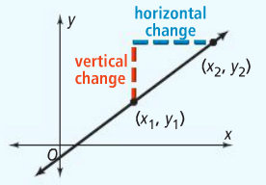You can describe movement in a coordinate plane by describing how far you need to move vertically and how far you need to move horizontally to get from one point to another point. Consider a non-vertical line in the coordinate plane. If you move from any point on the line to any other point on the line, the ratio of the vertical change to the horizontal change is constant. That constant ratio is the **slope** of the line.

The slope of a non-vertical line is the ratio of the vertical change to the horizontal change between two points. You can calculate slope by finding the ratio of the difference in the *y*-coordinates to the difference in the *x*-coordinates for any two points on the line.

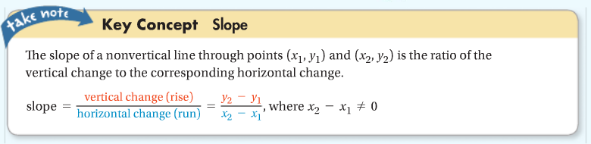

It will be very useful to remember the above formula because you will apply it for the rest of the chapter and in the future chapters.

**Example 1: Finding Slope**

What is the slope of the line that passes through the given points?

1. $(-3, 7)$ and $(-2, 4)$ $m=\frac{y_{2}-y_{1}}{x_{2}-x_{1}}=\frac{4-7}{-2-(-3)}=\frac{-3}{1}=-3$

It doesn’t make any difference if you choose $(-3, 7)$ as $\left(x_{1}, y_{1}\right)$ or $\left(x_{2}, y_{2}\right)$, as long as you plug it into the formula correctly, the answer will be the same either way.

Here I will use $(-3, 7)$ as $\left(x_{2}, y_{2}\right)$: $m=\frac{y_{2}-y_{1}}{x_{2}-x_{1}}=\frac{7-4}{-3-(-2)}=\frac{3}{-1}=-3$**TADA!!**

1. $(3, 1)$ and $(-4, 1)$ $m=\frac{y_{2}-y_{1}}{x_{2}-x_{1}}=\frac{1-1}{-4-3}=\frac{0}{-7}=0$
2. $(7, -3)$ and $(7, 1)$ $m=\frac{y_{2}-y_{1}}{x_{2}-x_{1}}=\frac{1-(-3)}{7-7}=\frac{4}{0}=Undefined$

**BIG QUESTION… What does the slope tell us about the line?**

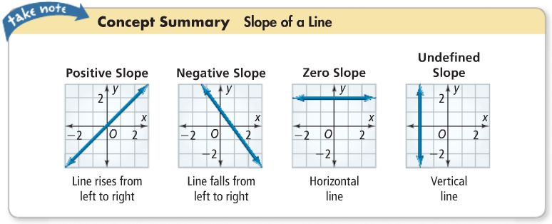

A function whose graph is a line is a **linear function**. You can represent a linear function with a **linear equation**, such as $y=2x+1$ or $y=-4x$. A solution of a linear equation is any ordered pair $(x, y)$ that makes the equation true (points on the line).

A special form of a linear equation is called **slope-intercept form**.

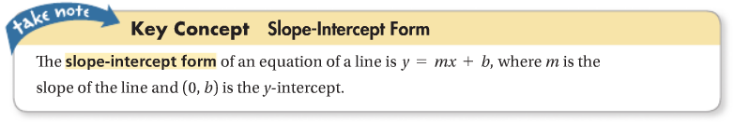

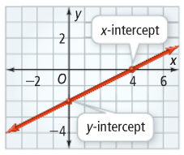

An **intercept** of a line is a point where a line crosses an axis. The ***y*-intercept** of a non-vertical line is the point at which the line crosses the *y*-axis. The ***x*-intercept** of a non-horizontal line is the point at which the line crosses the *x*-axis.

Using the graph on the right: *x*-intercept – $(4, 0)$

*y*-intercept – $(0, -2)$

**Remember:**

* The ordered pair *y*-value for any *x*-intercept is always zero – $(x, 0)$.
* The ordered pair *x*-value for any *y*-intercept is always zero – $(0, y)$.

**Example 2: Writing Linear Equations**

What is an equation of each line?

1. $m=\frac{1}{5}$ and the *y*-intercept is $(0, -3)$

Use the slope-intercept form to solve this problem:

$y=mx+b$ Substitute $m=\frac{1}{5}$ and $b=-3$.

$y=\frac{1}{5}x+(-3)$ Simplify.

$y=\frac{1}{5}x-3$

1. 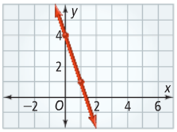

Looking at the line shown in the graph. The *y*-intercept is the point where the line crosses the *y*-axis, $\left(0, 4\right)$, so $b=4$.

**\*\*Remember, you will always need TWO POINTS to find the slope of any line!!\*\***

Now, use the second point $(1, 1)$ to find the slope.

$$m=\frac{y_{2}-y_{1}}{x_{2}-x_{1}}=\frac{1-4}{1-0}=\frac{-3}{1}=-3$$

So, $y=-3x+4$.

**Example 3: Writing Equations in Slope-Intercept Form**

You can rewrite a linear equation in slope-intercept form by solving for y.

Write the equation in slope-intercept form. What are the slope and *y*-intercept?

1. $5x-4y=16$ Subtract $5x$ from each side.

$-4y=-5x+16$ Divide each side by $-4$.

$\frac{-4y}{-4}=\frac{-5x}{-4}+\frac{16}{-4}$ Simplify.

$y=\frac{5}{4}x-4$ Compare the equation with $y=mx+b$.

The slope is $\frac{5}{4}$ and the *y*-intercept is $(0, -4)$.

1. $-\frac{3}{4}x+\frac{1}{2}y=-1$ Add $\frac{3}{4}x$ to each side.

$\frac{1}{2}y=\frac{3}{4}x-1$ Multiply each side by $2$.

$y=\frac{3}{2}x-2$ Compare the equation with $y=mx+b$.

The slope is $\frac{3}{2}$ and the *y*-intercept is $(0, -2)$.

**Example 4: Graphing a Linear Equation**

What is the graph of $-2x+y=1$?

It is always the best idea to rewrite the equation in slope-intercept form:

$-2x+y=1$ Add $2x$ to each side.

$y=2x+1$

The slope is $2$ and the *y*-intercept is $(0, 1)$.

**Use the following three steps to graph any linear equation:**

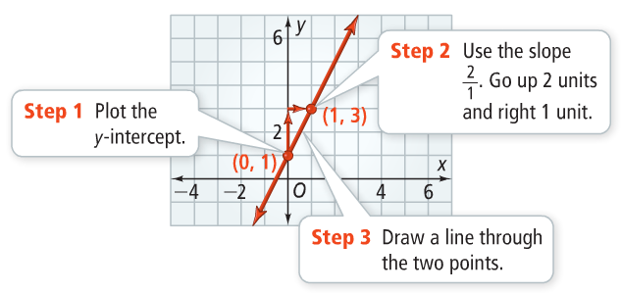

1. Plot the *y*-intercept.
2. Use the slope to find the second point.
3. Draw a line through the two points.